Tab 1


SECR1213-10
NETWORK COMMUNICATIONS

SEMESTER 1 SESSION 2025/2026

Project :
NETWORK DESIGN FOR FACULTY OF COMPUTING BLOCK N28B

LECTURER’S NAME : DR. ADNAN KHALID

NO | NAME | MATRICS
1 | NUR AQMAL IMANI BIN HASSNOR | A24CS8009
2 | MEGAT HAREZ ISKANDAR BIN MEGAT MUHAMMED FIRUZ | A24CS8011
3 | MUHAMMAD HAZIM BIN MISAMUDIN MUDA | A24CS8013
4 | MUHAMMAD RENDY ATSARY | A24CS9003

Table Of Contents

Abstract 5
1.0 Introduction 6
2.0 Project Background 7
3.0 Task 1: Project Setup 8
3.1 Floor plan requirements 8
3.2 Floor Plan 9
3.2.1 Ground Floor (GF) 9
3.2.2 1st Floor (L1) 11
3.3 Reflection on Task 1 13
● Design Process and Tools 13
● Challenges and Solutions 13
● Lessons Learned 14
● Conclusion 14
4.0 Task 2: Initial Design (Preliminary Analysis) 15
4.1 Why is Preliminary Analysis Conducted? 15
4.2 Questions and Answers 15
4.3 Feasibility Study 18
5.0 Task 3: Choosing The Appropriate LAN Devices 20
5.1 Identifying The Requirements Needed 20
5.2 Device List 20
5.3 Total Cost 32
5.4 Conclusion and Reflection 33
6.0 Task 4: Making A Connections to LAN & WAN 35
6.1 Overview of Physical Network Implementation 35
6.2 Identifying Work Areas 37
6.3 Cabling, Routing & Switching Connections 39
6.4 Conclusion and Reflection 48
7.0 Task 5: IP Addressing Schemes 50
7.1 Overview of IP Addressing 50
7.2 Assigned Network Addressing 50
7.3 Subnetting Strategy 51
7.4 IP Address Allocation Table 52
7.5 Justification of Design 53
7.6 Conclusion and Reflection 54
8.0 Project Conclusion and Reflection 55
9.0 Team Members and Responsibilities 58
References 60
Appendices 61

Table Of Figures

Figure 3.2.1.1: Floor Plan for Ground Floor (GF) of Block N28B 9
Figure 3.2.2.1: Floor Plan for 1st Floor (L1) of Block N28B 11
Figure 6.2.1.1: Work Areas for Ground Floor (GF) of Block N28B 37
Figure 6.2.2.1: Work Areas for 1st Floor (L1) of Block N28B 38
Figure 6.3.3.1: Wired LAN Cabling Structure for Labs on (GF & L1) 40
Figure 6.3.7.1: Physical Cabling and Connection Planning for Ground Floor (GF) 44
Figure 6.3.7.2: Physical Cabling and Connection Planning for 1st Floor (L1) 46

Abstract
This report outlines the design and implementation of a robust network infrastructure for the new Faculty of Computing (FC) building at Universiti Teknologi Malaysia (UTM), located in Block N28B. The project responds to the faculty’s projected 15% growth in student and staff numbers over the next four years, in line with the requirements of the Fourth Industrial Revolution (4IR). The network is designed to be scalable, high-performing, secure, and cost-effective, all within a budget of RM 900,000.
Major elements of the infrastructure include core and access layer switches, structured cabling, IP subnetting, Wi-Fi 6 wireless connectivity, VLAN-based segmentation, and backup systems utilizing both NAS and cloud storage. The network currently serves more than 1,940 users and is prepared for future IoT integration to support smart campus initiatives. The design addresses key challenges such as maintaining enterprise-grade reliability while staying within budget and ensuring redundancy, achieved through the use of Cisco networking hardware, Fortinet firewalls, and scalable access points. This project represents a strategic approach that meets present-day needs while positioning the faculty for future technological progress.

1.0 Introduction
The Network Communication Project (SECR1213) is an excellent opportunity for students to engage in a hands-on project where they are required to plan and design a local area network (LAN) for a real-life setting. Taking on the role of network consultants, the team is expected to deliver a proposal that is not only efficient but also secure, and scalable which will primarily focus on the network infrastructure of the Faculty of Computing (FC) at Universiti Teknologi Malaysia. This assignment is a clear illustration of the progression of the professional network design and documentation process from the underlying theoretical concepts of networking.
The case highlights that the FC intends to erect a new two-storey building, Block N28B, due to a predicted 15% rise in the number of students and staff over the next four years. It aims to provide four computer laboratories, a hybrid classroom, a video conferencing room, and a Wi-Fi-enabled student lounge. All laboratories will be equipped with 30 workstations and supported by high-speed connectivity to meet the digital needs of the Fourth Industrial Revolution (4IR).
The most important thing about Task 1 is the creation of the project scope which depends largely on the way in which teams are formed, how the case study is interpreted, and the nature of the floor-plan design. The group must organize team roles and responsibilities, produce the case study-compliant layout that is scaled and clearly labelled, and also, in the meeting minutes, keep track of the early planning progress.
This starting point of the group work sets the tone of the following tasks regarding the need for the team to comprehend fully the client’s wishes as well as the scope of the work before they can move on to the more detailed network planning, device selection, and configuration.

2.0 Project Background
The Faculty of Computing (FC) currently serves 1,800 students, including both undergraduate and postgraduate levels, along with 100 academic staff and 40 support staff. Anticipating a 15% increase in both student numbers and academic staff over the next four years, FC plans to construct a new two-storey building to accommodate this growth.
The proposed building will feature four laboratories, a video conferencing room for virtual project discussions, and a hybrid classroom. It will also include a student lounge designed as a collaborative and relaxing space, equipped with Wi-Fi connectivity.
Each laboratory and the student lounge will measure 14m x 10m, with all labs supported by high-speed internet access to meet the demands of education aligned with the Fourth Industrial Revolution (4IR). Each lab will be equipped with 30 workstations. The laboratories will consist of two general-purpose labs, one Cisco Network Lab (for network learning and implementation), and one Embedded Systems Lab (for IoT, digital electronics, sensors, and related studies).
The Cisco Network Lab will include networking devices suitable for teaching purposes, while the Embedded Systems Lab will feature tools and peripherals to support hands-on learning. The hybrid classroom will be optimized for interactive and efficient teaching and learning experiences.
The Dean of FC emphasized that the new building must be future-ready, featuring a reliable, secure, and efficient network infrastructure that is both easy to manage and cost-effective.

3.0 Task 1: Project Setup
The new two-storey Faculty of Computing (FC) building will be designed to optimize space utilization, functionality, and accessibility. Each floor will accommodate specific rooms and facilities tailored to support teaching, learning, and administrative needs. Below are the requirements as planned to implement.

3.1 Floor plan requirements
Ground Floor (GF)
1. General Purpose Lab 1
2. General Purpose Lab 2
3. Video Conference Room
4. Student Lounge
5. Server Room
6. Pantry
7. Men & Women Restroom

1st Floor (L1)
1. Cisco Network Lab
2. Embedded Lab
3. Office
4. Hybrid Classroom
5. Server Room
6. Men & Women Restroom

3.2 Floor Plan

3.2.1 Ground Floor (GF)
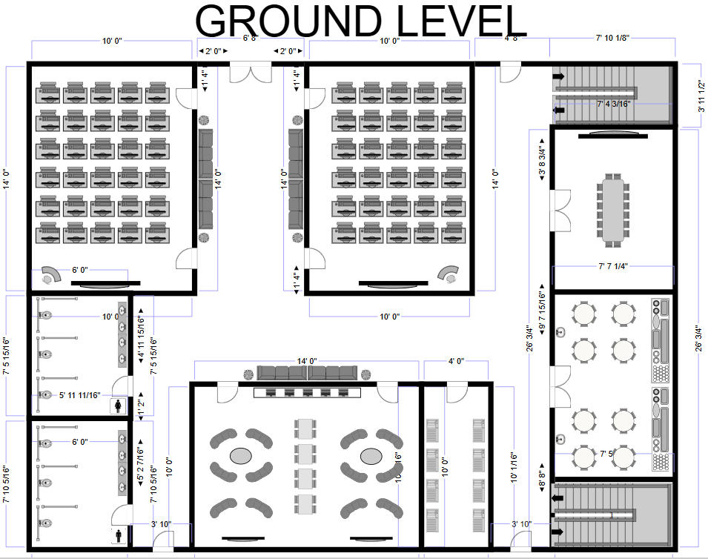
Men
Video Conference Room
General Lab 1
General Lab 2
Women
Pantry
To Level 1
Server
Student Lounge
Figure 3.2.1.1: Floor Plan for Ground Floor (GF) of Block N28B

What we can see on the ground floor:
- General Lab 1:
Equipped with a smartboard and also a total of 30 computers workstations for hands-on learning and practical exercises. Designed for small to medium-sized classes or group projects and also daily lectures. There is also a sitting area that’s been prepared for the next group of students or class to wait while the current class is ending.
- General Lab 2:
Similar to Lab 1, equipped with a smartboard and also a total of 30 computers workstations for hands-on learning and practical exercises. Designed for small to medium-sized classes or group projects and also daily lectures. There is also a sitting area that’s been prepared for the next group of students or class to wait while the current class is ending.
- Video Conference Room:
A dedicated space for online meetings, virtual collaborations, and remote lectures. Features a long table with seating for group discussions. It can also fit up to 16 peoples per session.
- Student Lounge:
A common area furnished with round and sofa-style seating for relaxation, socializing, or informal study sessions between classes. Also there is a long table for students to do their assignments or can be used for any other work related.
- Server Room:
Houses networking and data management equipment essential for maintaining the building’s digital and lab infrastructure.
- Pantry:
Serves as a refreshment and rest area where staff and students can prepare or enjoy light meals and beverages.
- Men & Women Restroom:
Separate restrooms for male and female users, located conveniently near the labs and classrooms for accessibility and comfort.

3.2.2 1st Floor (L1)
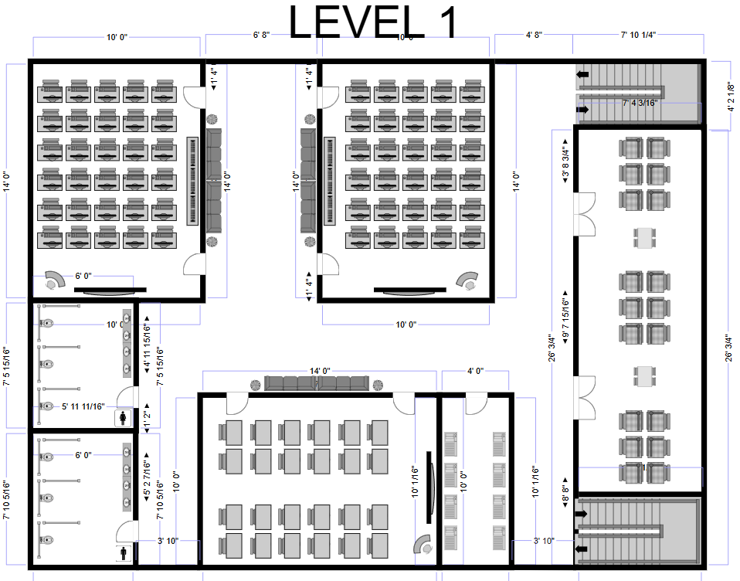
Office
Hybrid Classroom
Embedded System Lab
To Ground Floor
Cisco Network Lab
Server
Women
Men
Figure 3.2.2.1: Floor Plan for 1st Floor (L1) of Block N28B

What we can see on the 1st floor:
- Cisco Network Lab:
A specialized lab equipped for networking practice and simulations. Students use this space to configure routers, switches, and learn about computer network systems.
- Embedded System Lab:
Dedicated to microcontroller and hardware-based projects. Supports hands-on learning for embedded system design, programming, and prototyping.
- Office:
An administrative and academic workspace for faculty and staff. Used for meetings, grading, documentation, and coordination of departmental activities.
- Hybrid Classroom:
A flexible learning space designed for both face-to-face and online instruction. Accommodates lectures, presentations, and interactive sessions for up to 24 students.
- Server Room:
Contains critical network servers and data equipment. Supports connectivity, data storage, and system management for the building’s IT infrastructure. It also may contain backup images of data for the entire IT infrastructure.
- Men & Women Restroom:
Separate restrooms for male and female users, located conveniently near the labs and classrooms for accessibility and comfort.

3.3 Reflection on Task 1

Design Process and Tools
For this task, we used SmartDraw (Free Tier) to create the floor plan of the new Faculty of Computing building. The software provided an easy-to-use interface that helped us visualize and organize all the rooms efficiently. It allowed us to accurately include the required spaces such as labs, the hybrid classroom, the video conferencing room, and the student lounge while maintaining realistic proportions.

Challenges and Solutions
One of the main challenges was ensuring that all rooms fit within the two-storey design while keeping the flow of movement practical and accessible. Since only some room sizes were provided in the case study, we had to estimate reasonable dimensions for the other rooms. SmartDraw’s drag-and-drop tools made it easier to test multiple arrangements and compare layouts quickly. Another challenge was designing with future expansion in mind. We addressed this by leaving space for potential infrastructure additions like network equipment or flexible study areas.

Lessons Learned
Through this task, we learned the importance of combining functionality and flexibility in design. Planning for current needs while considering future growth is essential, especially in an educational environment that evolves with technology. Using SmartDraw also showed how digital design tools can save time, improve accuracy, and make collaboration easier during the planning process.

Conclusion
Designing the floor plan for the Faculty of Computing building was a valuable experience that blended creativity with technical planning. By using SmartDraw and focusing on efficient space utilization, modern connectivity, and adaptability, we designed a facility that supports learning, collaboration, and future technological advancements.

4.0 Task 2: Initial Design (Preliminary Analysis)

4.1 Why is Preliminary Analysis Conducted?
The main reason this preliminary analysis is conducted is to clearly identify and understand the technical, operational, and future requirements for the new Faculty of Computing building before designing the network infrastructure. This step ensures that the planned system can support current academic and administrative activities while preparing for future growth in student population, staff, and technological demands. By gathering essential information such as user capacity, device requirements, security needs, and connectivity expectations, the analysis helps stakeholders make informed decisions, avoid design errors, and plan a scalable, secure, and cost-effective network. Ultimately, this process establishes a strong foundation for determining the feasibility of the project and guiding the development of an efficient and future-ready network solution.

4.2 Questions and Answers
- What is the estimated number of users who will access the network initially and in the future?
- Answer: The current users include 1,800 students, 100 academic staff, and 40 supporting staff. With a projected 15% growth in four years, the estimated future population is approximately 2,070 students and 115 staff.

- What are the specific spaces included in the new building and their intended functions?
- Answer: The building will include 4 labs (30 workstations each), 1 video conferencing room, 1 hybrid classroom, 1 student lounge with Wi-Fi, and supporting spaces.

- What are the dimensions of the lab and student lounge spaces?
- Answer: Each lab and student lounge is 14m x 10m, providing adequate space for 30 networked workstations and lab equipment.

- What are the network performance expectations for the labs and building?
- Answer: The network must support high-speed data, low latency, and high reliability to support 4IR learning activities, IoT development, and hybrid teaching.
- Reference By: Ministry of Higher Education Malaysia – Digital Campus Guideline (4IR emphasis)

- What type of equipment will be needed in the Cisco Networking Lab?
- Answer: The Cisco Lab will require Cisco routers, switches, firewalls, and network simulation tools, suitable for hands-on network implementation training.
- Reference By: Cisco Networking Academy Equipment List - Ontario Tech NetLab Equipment

- What equipment and devices will be required in the Embedded Lab?
- Answer: The Embedded Lab will require IoT kits, microcontrollers, sensors, embedded boards, and test equipment, all connected to the network.
- Reference By: ResearchGate - “Design & Implementation of Embedded & IoT Lab Kits”, Keysight IoT Lab Solution

- Will the building require both wired and wireless connectivity, and what are the expected coverage areas?
- Answer: Yes. All labs, classroom, and staff areas will use wired connectivity for reliability and performance. The student lounge and all common areas require high-speed secure Wi-Fi with high-density support. Coverage must include the entire building.
- Reference By: IEEE Wi-Fi Campus Deployment Standards

- What type of security requirements are expected?
- Answer: The network must incorporate firewalls, intrusion prevention, secure authentication, and protection against DoS attacks, internet worms, and e-application threats.
- Reference By: Cisco Cybersecurity Framework for Higher Education

- What is the expectation regarding network management and scalability?
- Answer: The system must be easy to manage, support future expansion, and integrate with existing faculty systems without service disruption.
- Reference By: Cisco Enterprise Network Design Guide

- What is the expected network backbone and performance requirement?
- Answer: The backbone must support high-performance links (e.g., 10Gbps or higher) to maintain smooth academic and research operations.
- Reference By: Cisco Enterprise Network Design Model

- What budget constraints should be considered?
- Answer: The system must be cost-effective, forward-compatible, and not excessively expensive to maintain over long periods ("not paying for 20 years").

- Will hybrid or remote learning features be required?
- Answer: Yes. The hybrid classroom and video conferencing room must support high-quality video collaboration and smart classroom technology.
- Reference By: UNESCO Hybrid Learning Strategy / Post-Pandemic Higher Ed Technology Guidelines

4.3 Feasibility Study
The preliminary analysis indicates that the proposed network infrastructure for the new Faculty of Computing building is feasible. The planned facilities include four specialized labs, a hybrid classroom, and a student lounge aligned with the faculty’s academic needs and projected growth. Modern networking solutions, such as high-speed Ethernet, enterprise Wi-Fi, and secure scalable infrastructure, are readily available and capable of supporting hybrid learning, IoT development, video conferencing, and future digital-learning environments. While the project requires notable investment, its scalability and emphasis on cost-effective equipment ensure long-term value and avoid frequent upgrades. Therefore, the project is technically achievable, financially practical, and operationally beneficial for supporting current and future academic activities.

- Technical Feasibility

  - The project is technically feasible because all required networking technologies are available and suitable for modern educational environments. The building can be equipped with high-speed fiber internet, structured CAT6/CAT6A cabling, enterprise-class network switches, secure firewalls, wireless access points, and server equipment. The computer labs, including the Cisco Network Lab and Embedded Lab, can be fitted with industry-standard devices for hands-on learning. The network will also support hybrid learning systems, IoT devices, video conferencing, and cybersecurity protection, making the design technologically reliable and future-ready.

- Economic Feasibility

  - The project is economically feasible because the investment supports the faculty’s growth and long-term academic needs. Although initial implementation requires purchasing equipment and installation services, choosing scalable and cost-effective devices ensures good value over time. Using industry-standard and modular hardware allows future upgrades without replacing the entire system. This reduces long-term costs and ensures the network remains efficient and affordable for the faculty.

- Operational Feasibility

  - The network fully supports the day-to-day operations of the faculty, including teaching, learning, research, and administrative work. High-speed wired connections will be used in labs and staff rooms, while secure Wi-Fi will be provided in the student lounge and other common areas. The hybrid classroom and video conferencing room will improve teaching flexibility and support online learning. This ensures that the network improves productivity and supports modern educational activities effectively.

- Future / Scalability Feasibility

  - The project supports future expansion and growth. The faculty expects student and staff numbers to increase by 15% in the next four years, and the network design can scale accordingly. Additional switches, access points, and server capacity can be added without major redesign. Extra cable pathways and rack space will allow for new devices and future technology upgrades. This ensures the network remains functional, flexible, and able to accommodate new learning requirements and technological advancements.

5.0 Task 3: Choosing The Appropriate LAN Devices

5.1 Identifying The Requirements Needed

With the network design, interviews, and research completed, the next step is to identify the exact network and end-user devices needed to meet the institution’s requirements. Because devices like routers, switches, wireless access points, and cabling come in many brands and performance levels, it is important to evaluate which options best suit an academic environment. This task requires careful research and comparison to ensure the chosen devices provide reliability, scalability, and value for the organization.

5.2 Device List
The devices needed for the institution are categorized based on their function within the network architecture. This ensures each layer of the network is equipped with devices designed for its specific operational role.

5.2.1 Core Infrastructure

1. Cisco ISR 4321-SEC/K9
Device | Cisco ISR 4321-SEC/K9
Specification | - 2 × Gigabit Ethernet (RJ-45) ports  - 1 × SFP port  - 2 × NIM slots  - 4GB DDR3 DRAM (upgradable to 8GB)  - 4GB Flash memory (upgradable to 8GB)  - Aggregate throughput: 50Mbps – 100Mbps (with performance license)  - Power: External AC / PoE
Description | Branch router with built-in security features (firewall, IPsec)
Why Chosen (Premium Academic Use) | Ideal when security is needed at the edge, good for networks requiring encrypted WAN or VPN
Estimated Cost (RM) | RM 8,868
Reference | Cisco Official

2. Cisco Catalyst 9500-24Q
Device | Cisco Catalyst 9500-24Q (Core Switch)
Specification | 24 × 40Gbps QSFP+ ports, enterprise-grade core switching, high throughput
Description | Acts as the main core backbone switch for the entire 2-storey building
Why Chosen (Premium Academic Use) | Provides high-speed aggregated switching needed for labs, servers, and Wi-Fi; stable for large campus networks
Estimated Cost (RM) | RM 120,000
Reference | Cisco Official

3. 42U Server Rack + Cable Management
Device | 42U Server Rack + Accessories
Specification | Fits servers, patch panels, switches, airflow design
Description | Physical enclosure for structured cabling and core devices
Why Chosen (Premium Academic Use) | Supports campus-scale organization and maintainability
Estimated Cost (RM) | RM 8,000
Reference | Industry Standard

4. Dell PowerEdge R750 Server
Device | Dell PowerEdge R750
Specification | Dual Xeon CPUs, 64GB RAM, NVMe storage
Description | Hosts DHCP, DNS, authentication (AD), LMS/academic services
Why Chosen (Premium Academic Use) | Reliable campus-grade server with future scalability
Estimated Cost (RM) | RM 45,000
Reference | Dell Official

5. Patch Panels (Cat 6A)
Device | Cat 6A 48-Port Patch Panels
Specification | 10Gbps rated, rack-mount
Description | Required for structured cabling termination
Why Chosen (Premium Academic Use) | Ensures stable high-speed performance
Estimated Cost (RM) | RM 1,000 × 10 = RM 10,000
Reference | Generic Standard

6. Cat 6A UTP Cabling
Device | Cat 6A Cabling Infrastructure
Specification | 10Gbps UTP cable, complete building installation
Description | Backbone and horizontal cabling for all rooms and labs
Why Chosen (Premium Academic Use) | Supports future bandwidth and network upgrades
Estimated Cost (RM) | RM 60,000
Reference | -

7. APC Smart-UPS 10kVA
Device | APC Smart-UPS 10kVA
Specification | 10,000VA battery backup, surge protection
Description | Protects servers, switches, and core network equipment
Why Chosen (Premium Academic Use) | Ensures uptime for labs and hybrid learning
Estimated Cost (RM) | RM 25,000
Reference | APC

5.2.2 Access Layer and End-User Devices

1. Cisco Catalyst 9300-48P
Device | Cisco Catalyst 9300-48P (Access Switch)
Specification | 48-port PoE+, advanced Layer 3 switching, StackWise support
Description | Main access switch for labs, APs, video rooms, and staff offices
Why Chosen (Premium Academic Use) | Supports high-density labs, secure segmentation, and PoE+ for APs
Estimated Cost (RM) | RM 38,000 × 8 = RM 304,000
Reference | Cisco Official

2. Cisco Catalyst 9136 Wi-Fi 6E AP
Device | Cisco Catalyst 9136 (Wi-Fi 6E Access Point)
Specification | Tri-band, 6GHz support, high-density MIMO
Description | Wireless access point for student lounge, classrooms, and labs
Why Chosen (Premium Academic Use) | Handles large student spaces with Wi-Fi 6E performance
Estimated Cost (RM) | RM 6,500 × 20 = RM 130,000
Reference | Cisco Official

3. Cisco Catalyst 9800-40 WLC
Device | Cisco 9800-40 Wireless LAN Controller
Specification | Supports 2,000 clients, 50 APs, secure wireless architecture
Description | Centralizes and manages all APs in the building
Why Chosen (Premium Academic Use) | Designed for medium–large academic campuses
Estimated Cost (RM) | RM 85,000
Reference | Cisco Official

4. High-End Lab Workstations
Device | Advanced Lab Workstations
Specification | Intel i7 / Ryzen 7, 16GB RAM, 512GB SSD
Description | For Cisco simulations, IoT programming, coding labs
Why Chosen (Premium Academic Use) | Required for Packet Tracer, GNS3, IoT SDKs
Estimated Cost (RM) | RM 4,500 × 120 = RM 540,000
Reference | HP / Dell

5. 4K Laser Projectors
Device | 4K Laser Classroom Projectors
Specification | 4K resolution, 3,500–5,000 lumens
Description | Used in lecture rooms, hybrid teaching classrooms
Why Chosen (Premium Academic Use) | High brightness and low maintenance
Estimated Cost (RM) | RM 9,000 × 6 = RM 54,000
Reference | Epson / Sony

6. Cisco VoIP Phones
Device | Cisco VoIP Phones
Specification | HD calling, PoE support, SIP/Unified CM
Description | Staff office telecommunication
Why Chosen (Premium Academic Use) | Integrates with university voice network
Estimated Cost (RM) | RM 900 × 20 = RM 18,000
Reference | Cisco
7. Interactive Smartboard
Device | Interactive Smartboard
Specification | 75″–85″ touch display, annotation tools
Description | Touch-enabled interactive teaching board
Why Chosen (Premium Academic Use) | Supports collaborative hybrid teaching
Estimated Cost (RM) | RM 6,000 × 2 = RM 12,000
Reference | Samsung / BenQ

8. Video Conferencing System
Device | Enterprise Video Conferencing System
Specification | Mic array, 4K camera, codec system
Description | For the video conferencing room
Why Chosen (Premium Academic Use) | Premium-quality hybrid meetings
Estimated Cost (RM) | RM 25,000
Reference | Poly / Logitech Rally

5.2.3 Security, Control and Backup

1. Cisco Firepower 1140 NGFW
Device | Cisco Firepower 1140 Next-Generation Firewall
Specification | IPS, IDS, anti-malware, DoS protection
Description | Protects the building network and all connected users
Why Chosen (Premium Academic Use) | Required for secure research environments and student usage
Estimated Cost (RM) | RM 25,000
Reference | Cisco Firepower

2. Cisco Identity Services Engine (ISE)
Device | Cisco ISE (Network Access Control System)
Specification | 802.1X authentication, user/device profiling, guest access control
Description | Provides authentication and identity-based access control for students, staff, IoT devices, and lab equipment.
Why Chosen (Premium Academic Use) | Ensures only authorized users and devices are allowed into the network; required for secure campus environments.
Estimated Cost (RM) | RM 70,000
Reference | Cisco ISE Official Documentation

3. Centralized Backup System (NAS/SAN Storage)
Device | Synology RackStation RS4021xs+ or Dell EMC Unity XT
Specification | Up to 40TB storage, RAID protection, snapshot backup, VM backup
Description | Stores server backups, user profiles, LMS data, and lab configuration backups.
Why Chosen (Premium Academic Use) | Protects against data loss, ensures business continuity, supports automated daily backup.
Estimated Cost (RM) | RM 50,000
Reference | Synology / Dell EMC

4. CCTV NVR Security Storage
Device | Network Video Recorder (NVR) 32-Channel
Specification | Supports multiple 4K cameras, RAID storage
Description | Stores recordings from PTZ cameras and security cameras around the building.
Why Chosen (Premium Academic Use) | Provides long-term video retention for compliance and safety.
Estimated Cost (RM) | RM 15,000
Reference | HikVision / Uniview

5.2.4 Communication, Monitoring and Management

1. Auto-Tracking PTZ Cameras
Device | Auto-Tracking PTZ Cameras
Specification | 4K PTZ, auto-tracking, wide-angle
Description | For hybrid learning, focuses on lecturer movement
Why Chosen (Premium Academic Use) | Essential for hybrid classroom pedagogy
Estimated Cost (RM) | RM 8,000 × 3 = RM 24,000
Reference | Aver / Logitech

2. Network Management Server (SNMP/NMS System)
Device | PRTG / SolarWinds NPM
Specification | Traffic monitoring, device uptime, alerting
Description | Monitors switches, routers, servers, wireless controllers, and CCTV systems.
Why Chosen (Premium Academic Use) | Ensures proactive detection of network failures, crucial for academic scheduling.
Estimated Cost (RM) | RM 20,000
Reference | SolarWinds / PRTG Official

3. Unified Communication Server (UC System)
Device | Cisco Unified Communications Manager (CUCM)
Specification | VoIP management, call routing, directory integration
Description | Manages all VoIP phones and video conferencing endpoints.
Why Chosen (Premium Academic Use) | Provides professional communication for staff offices and academic activities.
Estimated Cost (RM) | RM 60,000
Reference | Cisco CUCM

5.3 Total Cost

The total cost calculation is derived by aggregating the estimated costs of all core, access, security, and communication devices identified in Section 5.2. The estimated total cost for the proposed network infrastructure, featuring premium academic-use hardware, is presented below.

Category | Sub-Total Estimated Cost (RM)
Core Infrastructure (5.2.1) | RM 276,868
Access Layer & End-User Devices (5.2.2) | RM 1,168,000
Security, Control, and Backup (5.2.3) | RM 160,000
Communication, Monitoring, and Management (5.2.4) | RM 104,000
GRAND TOTAL COST | RM 1,708,868

Summary: The total estimated cost for the complete device and cabling infrastructure required for the Faculty of Computing Block N28B is RM 1,708,868.

5.4 Conclusion and Reflection

5.4.1 Conclusion
The network design project for the Faculty of Computing Block N28B has been successfully concluded; it details a comprehensive infrastructure proposal able to support the projected 15% increase in the student and staff population over the next four years. With the integration of the physical floor plan design with a rigorous needs analysis, the proposed network architecture meets the demands of the 4IR through the provision of high-speed connectivity, IoT-ready laboratories, and hybrid learning facilities.
The final design includes enterprise-grade hardware at its core, utilizing the Cisco Catalyst 9000 series for core and access switching. Crucially, the design ensures high-density wireless coverage in the student lounge and common areas through the deployment of Wi-Fi 6E technology. Furthermore, the integration of robust security features, specifically the Cisco Firepower NGFW and Identity Services Engine, secures this academic environment from digital attacks while maintaining ease of access for authorized users.

5.4.2 Reflection
Throughout the execution of this project, a number of critical lessons were learned regarding the complexity of professional network design:
1. Balancing Performance vs. Cost:
- The most significant learning curve was the trade-off between "Premium Academic Use" and budget constraints. Whereas the initial abstract estimated a budget of RM 900,000, the detailed device selection process in Task 3 resulted in a total estimated cost of RM 1,708,868. This variance demonstrates that truly enterprise-grade and future-proof equipment is highly capital-intensive. We deliberately opted for premium devices, such as the Cisco Catalyst 9500 Core Switch and Wi-Fi 6E APs, to avoid major network upgrades in the near future, confirming that long-term scalability often requires higher initial capital expenditure.
2. The Importance of Physical Planning:
- The use of SmartDraw in Task 1 demonstrated that network design is not only about electronic connectivity but also physical constraints. To effectively plan cable runs, identifying the specific locations for the Server Rooms on the Ground Floor and 1st Floor was critical in ensuring that the 10Gbps backbone could physically reach all laboratories and the hybrid classroom.
3. Future-Proofing for 4IR:
- Designing for the "now" is inadequate. By incorporating equipment for an Embedded Systems Lab and a Cisco Network Lab, we realized that the infrastructure must support not just standard internet traffic but also heavy simulation loads, video conferencing traffic, and IoT device density.
In summary, this project provided a holistic view of network engineering. It showed that a successful network is built on a foundation of thorough preliminary analysis, strategic hardware selection, and a willingness to invest in quality infrastructure to guarantee operational continuity and educational excellence.

6.0 Task 4: Making A Connections to LAN & WAN

6.1 Overview of Physical Network Implementation

6.1.1 Introduction to Physical Network Implementation
This task focuses on translating the proposed network design into a practical physical implementation by defining how all networking devices and infrastructure are interconnected within the building and to the wider institutional network. The objective is to ensure reliable communication, high performance, scalability, and security for an academic environment that supports laboratories, classrooms, offices, and hybrid learning facilities.
The network design follows a hierarchical architecture, consisting of core, access, and edge layers, and considers four main physical areas (work area, the server room, backbone/vertical cabling, and horizontal cabling). Appropriate transmission media, including twisted pair copper, fiber optic, and wireless, are selected based on performance requirements, distance limitations, and future scalability.

6.1.2 The Server Room (Distribution Facility)
A centralized Server Room is located on the ground floor, acting as the main distribution facility for the entire two-storey building. All core networking devices are housed inside a 42U server rack to ensure structured cabling, proper airflow, physical security, and ease of maintenance.
The following devices are installed in the server room:
- Cisco Catalyst 9500-24Q Core Switch: Serves as the backbone switch aggregating all access layer connections.
- Cisco ISR 4321 Router: Provides WAN connectivity to the main institution network and supports secure VPN or encrypted links.
- Cisco Firepower 1140 NGFW: Positioned at the network edge to protect internal users from external threats.
- Dell PowerEdge R750 Server: Hosts core services such as DHCP, DNS, authentication, LMS, and management systems.
- Cisco Catalyst 9800-40 Wireless LAN Controller: Centrally manages all wireless access points.
- Cisco ISE Server: Enforces network access control and authentication.
- Centralized Backup Storage (NAS/SAN): Stores backups and critical academic data.
- APC Smart-UPS 10kVA: Provides power protection and uninterrupted operation for all critical equipment.
All devices are interconnected using Cat 6A patch panels, ensuring organized cable management and easy troubleshooting.

6.2 Identifying Work Areas
6.2.1 Work Areas on Ground Floor (GF)

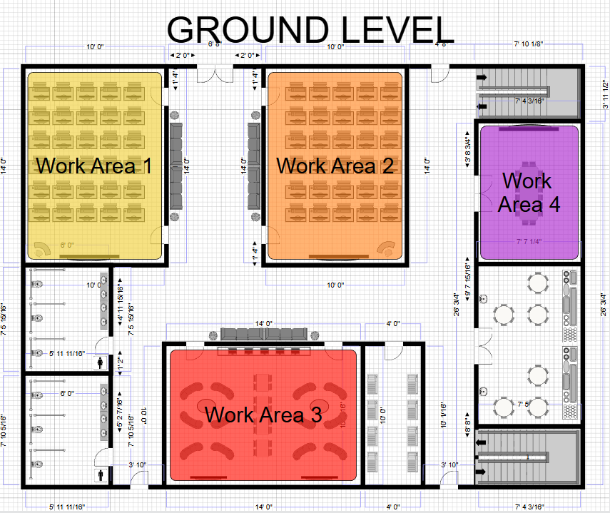
Server Room 1

Figure 6.2.1.1: Work Areas for Ground Floor (GF) of Block N28B

The Ground Floor is divided into four specific Work Areas to organize network cabling and distribution. Work Areas 1 and 2 cover the General Labs, requiring high-density wired connections for workstations. Work Area 3 (Student Lounge) is located adjacent to Server Room 1, resulting in the shortest cabling runs of approximately 10-12 meters. Conversely, Work Area 4 (Video Conference Room) is the furthest zone, requiring the longest cable paths to reach the backbone. All areas connect back to the Server Room via Cat 6A cabling.
6.2.2 Work Areas on 1st Floor (L1)

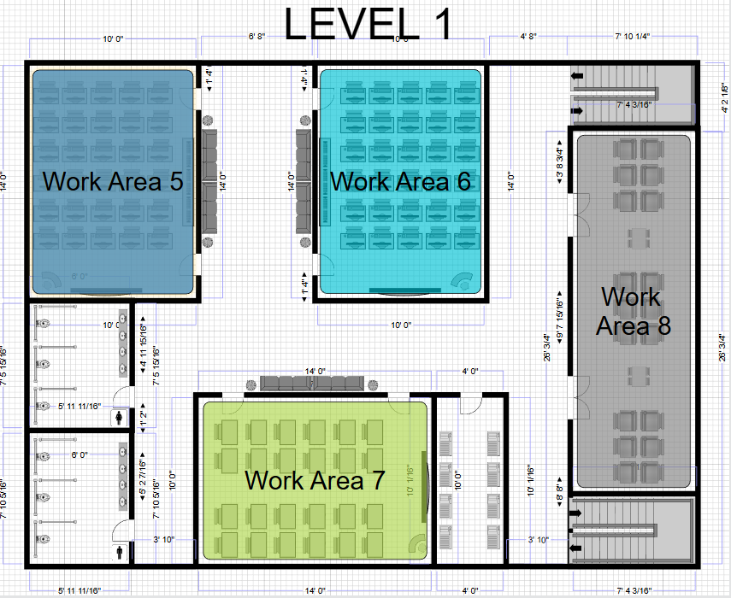

Server Room 2
Figure 6.2.2.1: Work Areas for 1st Floor (L1) of Block N28B

The First Floor is divided into four designated Work Areas to facilitate organized network cabling and distribution. Work Areas 5 and 6 serve as general workspaces, requiring standard wired connections for typical workstation setups. Work Areas 7 and 8 are positioned adjacent to Server Room 2, enabling the shortest cabling runs and optimal backbone access. Server Room 2 acts as the central distribution point for this level, with all areas connected via Cat 6A cabling. Work Areas 5 and 6 are located further from Server Room 2, these zones require moderate cable lengths and structured routing to maintain performance. Work Areas 7 and 8 are positioned directly beside Server Room 2, allowing for minimal cabling distances and efficient network access. Server Room 2 is the backbone hub for 1st Floor, supporting all work areas with high-speed Cat 6A connectivity.

6.3 Cabling, Routing & Switching Connections
6.3.1 Backbone (Vertical Cabling)

To connect the ground floor and first floor, fiber optic cabling is used as the backbone (vertical cabling). Fiber is selected due to its:

- High bandwidth capability
- Immunity to electromagnetic interference
- Support for long-distance transmission
- Future-proof scalability

Each floor’s access switches are connected to the core switch using fiber uplinks, ensuring high-speed communication between floors and preventing bottlenecks during peak academic usage.

6.3.2 Horizontal (Distribution Cabling)

Horizontal cabling distributes network connectivity from the telecommunications room to individual rooms, laboratories, classrooms, and offices on each floor.

- Cat 6A UTP cabling is used for all horizontal connections.
- Each outlet connects back to the patch panels in the TR.
- Cisco Catalyst 9300-48P access switches provide PoE+ to:
  - Wireless access points
  - VoIP phones
  - PTZ cameras
  - Network-enabled teaching devices

Cat 6A is chosen because it supports 10 Gbps speeds, reduces crosstalk, and ensures long-term performance for high-density academic environments.

6.3.3 Work Area Connections

The work area refers to locations where end users access the network on both the Ground Floor (GF) and 1st Floor (L1). These areas are designed to support a mix of fixed, mobile, and high-performance devices.

- Laboratories (GF & L1):
- High-end workstations are connected using wired Ethernet to ensure low latency, high throughput, and reliable performance for laboratory-based activities, simulations, and hands-on technical work.
- Example of Wired LAN cabling structure:
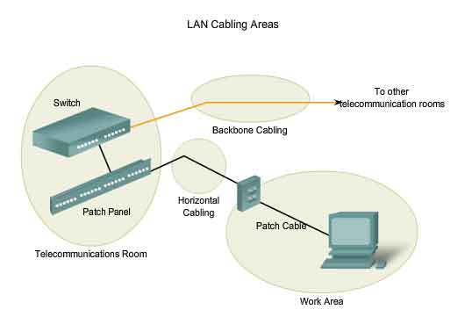
Figure 6.3.3.1: Wired LAN Cabling Structure for Labs on GF & L1

- Video Conference Room (GF):
- This area is connected via wired Ethernet to support video conferencing systems, display equipment, and VoIP phones powered through Power over Ethernet (PoE), ensuring stable and uninterrupted communication.

- Hybrid Classroom (L1):
- Hybrid classrooms are equipped with projectors, smartboards, PTZ cameras, instructor workstations, and dedicated wired network points to support blended learning, online lectures, and multimedia streaming.

- Office (L1):
- Staff offices are provided with wired Ethernet connections for desktop computers, printers, and VoIP phones, ensuring secure and consistent network access for administrative tasks.

- Student Lounge and Common Areas (GF & L1):
- These areas are primarily served via wireless connectivity to support student-owned devices such as laptops, tablets, and smartphones, offering flexibility and ease of access.

Each device within a work area connects to the nearest access switch through wall-mounted network outlets, following structured cabling standards to simplify maintenance and future expansion.

6.3.4 Wireless Connectivity

Wireless connectivity across both the Ground Floor (GF) and 1st Floor (L1) is provided using Cisco Catalyst 9136 Wi-Fi 6E access points, which are strategically ceiling-mounted to ensure uniform coverage and optimal signal performance. Wireless access points are deployed in the following areas on both floors:

- Laboratories
- Video Conference Room
- Hybrid Classroom
- Office
- Student Lounge and Common Areas

These APs connect to PoE-enabled access switches and are centrally managed by the Cisco Catalyst 9800-40 Wireless LAN Controller, enabling centralized configuration, security enforcement, and performance optimization.

Wi-Fi 6E is selected to support:
- High user density during peak academic hours
- Low latency applications such as video conferencing and real-time collaboration
- Modern student and staff devices
- Hybrid and flexible learning environments across multiple floors
6.3.5 WAN Connectivity

WAN connectivity is established using the Cisco ISR 4321 router, which links the building’s LAN to the main institutional network or internet service provider. The router supports:

- Secure WAN routing
- VPN and IPsec encryption
- Integration with the institution’s core network

Traffic entering or leaving the building is filtered and inspected by the Cisco Firepower 1140 NGFW, ensuring secure access to external resources.

6.3.6 Media Selection & Capabilities

Media Type | Usage | Capabilities | Limitations
Cat 6A UTP | Horizontal cabling | Up to 10 Gbps, cost-effective | Limited distance (100m)
Fiber Optic | Backbone/vertical links | Very high bandwidth, long distance | Higher cost
Wireless (Wi-Fi 6E) | Mobility areas | High-speed, flexible access | Shared medium, interference

Each media type is selected based on performance needs, installation environment, and cost-effectiveness.

6.3.7 Cabling, Routing & Switching Design on the Floor Plan

1. Physical Cabling and Connection Planning (Ground Floor)

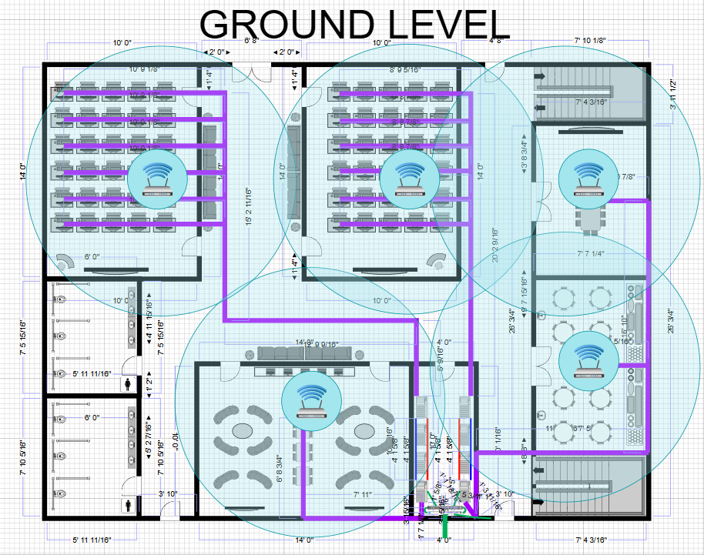
Server Room 1
Work Area 2

Work Area 4
Work Area 1
Work Area 3
Figure 6.3.7.1: Physical Cabling and Connection Planning for Ground Floor (GF)

More Explanation on Ground Floor’s Network Design Connections

Based on the finalized floor plan, the server room is strategically located adjacent to Work Area 3 to minimize cabling distances and improve network efficiency. Structured horizontal cabling is deployed only to the main work areas that require wired connectivity, while wireless access points (APs) are installed within each work area to provide seamless Wi-Fi coverage. This hybrid approach balances performance, flexibility, and cost-effectiveness.

Cat 6A UTP cabling is used for all wired connections to support up to 10 Gbps data rates, ensuring reliable high-speed access for laboratory workstations and future network upgrades. Each workstation in the highlighted work areas is connected via dedicated data points that terminate at patch panels in the server rack. Cable routing is carried out through cable trays and wall conduits, with additional slack included for maintenance and expansion.

Wireless access points are strategically installed in each work area to provide full Wi-Fi coverage for mobile devices such as laptops, tablets, and smartphones. This design ensures consistent signal strength and supports high user density without requiring excessive cabling to every location. Other non-critical areas rely primarily on wireless connectivity, reducing cabling complexity and installation cost.

Work Area 3, being closest to the server room, requires the shortest cable runs of approximately 10–12 meters per outlet. Work Areas 1 and 2 require medium-length runs of approximately 25–30 meters, while Work Area 4 requires the longest runs due to its location. Including routing allowances and contingency, the estimated total horizontal cabling required for the ground floor is approximately 2,500 meters of Cat 6A cable.

This cabling and wireless design ensures high performance, ease of management, scalability, and reliable connectivity across the entire ground floor.

2. Physical Cabling and Connection Planning (1st Floor)

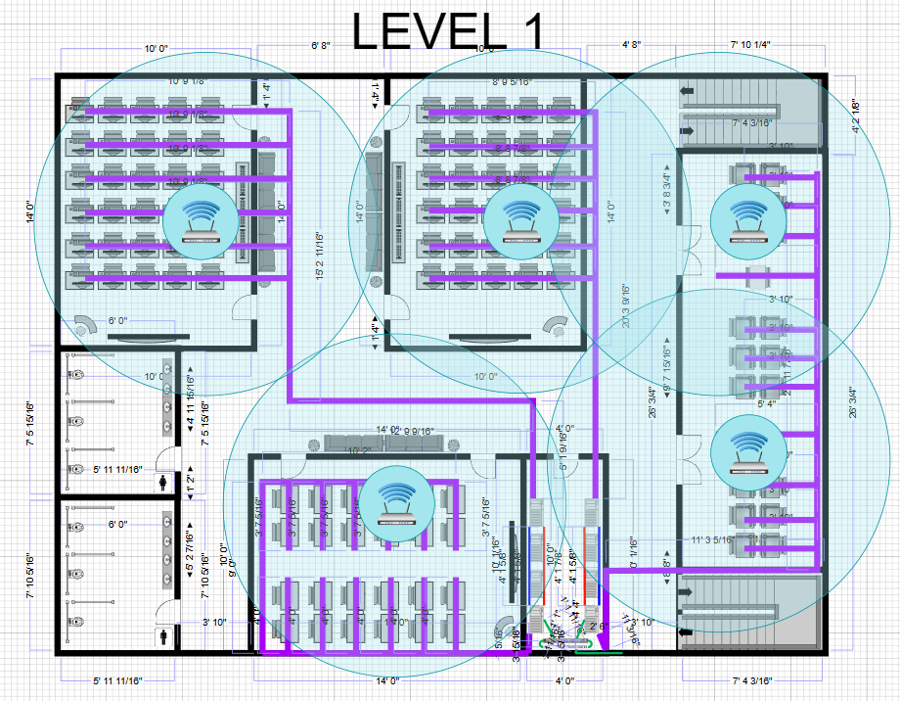
Work Area 5
Work Area 7

Server Room 2
Work Area 6
Work Area 8
Figure 6.3.7.2: Physical Cabling and Connection Planning for 1st Floor (L1)

More Explanation on 1st Floor’s Network Design Connections
The 1st Floor 1 network cabling design follows the same structured cabling principles used on the ground floor to ensure consistency, reliability, and ease of management. The work areas on 1st Floor consist of Work Area 5, Work Area 6, Work Area 7, and Work Area 8, which represent the main teaching and administrative spaces that require both wired and wireless connectivity.
All wired connections on 1st Floor are implemented using Cat 6A UTP horizontal cabling to support high-speed data transmission of up to 10 Gbps. Horizontal cabling from each work area is routed vertically through backbone risers to the core network infrastructure located near the server room on the ground floor. This vertical backbone connection ensures efficient inter-floor connectivity while minimizing signal loss and simplifying troubleshooting. Proper cable management systems and conduits are used to maintain organized and secure cable routing between floors.
Work Areas 5 and 6, which house computer-based laboratory environments, are equipped with dedicated wired network points for each workstation to ensure stable and low-latency connectivity required for network simulations, embedded systems development, and hands-on learning activities. Work Area 7, which functions as a hybrid classroom, is provided with wired connections for the instructor’s workstation, smartboard, video conferencing equipment, and control systems. Work Area 8, which serves as an office or administrative space, is provisioned with wired connections for staff computers, VoIP phones, and shared network devices.
Wireless access points are strategically installed within each 1st Floor work area to provide seamless Wi-Fi coverage for mobile devices such as laptops, tablets, and smartphones. This ensures consistent wireless performance, supports high user density during peak usage hours, and reduces the need for excessive cabling in non-fixed seating areas. Wireless coverage is designed to complement the wired network rather than replace it, ensuring both flexibility and performance.
Overall, the 1st Floor cabling and wireless design supports high-speed access, secure connectivity, and scalability. By combining structured horizontal cabling, vertical backbone connections, and well-planned wireless deployment, the network infrastructure on 1st Floor is capable of supporting current academic needs while remaining adaptable to future expansion.

6.4 Conclusion and Reflection
6.4.1 Conclusion

Task 4 successfully concludes the network design phase for the Faculty of Computing Block N28B through the development of a comprehensive physical network infrastructure plan. By translating the logical topology defined in Task 3 into a structured physical cabling design, the proposed solution ensures that the selected enterprise-class networking hardware can operate at its maximum efficiency and reliability.

The final physical implementation complies with TIA/EIA-568 structured cabling standards and adopts a Hierarchical Star Topology. A Main Distribution Frame (MDF) is installed on the Ground Floor, while an Intermediate Distribution Frame (IDF) is deployed on 1st Floor, interconnected using OM4 multimode fiber optic cabling. This design enables seamless high-bandwidth communication between floors while ensuring that all horizontal copper links remain within the 90-meter permanent link limitation.

Approximately 5.8 kilometers of Cat 6A cabling is installed to support laboratories, office spaces, and Wi-Fi 6E access points. This infrastructure is sufficient for current gigabit networking requirements and provides a scalable foundation for future 10-Gigabit Ethernet expansion without the need for disruptive recabling.

6.4.2 Reflection

The completion of the physical design phase provided a valuable practical perspective on the theoretical concepts of network engineering. Three key lessons were gained:

1. Layer 1 Logistics:
- The importance of Layer 1 planning became evident, particularly in high-density areas such as general laboratories. Calculating cable lengths demonstrated that network connectivity is not merely conceptual but involves extensive physical infrastructure. Effective planning must therefore account not only for data transmission but also for cable routing, organization, and management.
2. Strategic Topology Planning
- The decision to implement an IDF on 1st Floor highlighted how network topology is constrained by building layout and signal attenuation limits. Connecting all areas directly to a single server room was not feasible within cabling standards, reinforcing the importance of thorough site analysis as introduced in Task 1.
3. Future-Readiness in Cabling Design
- While active network components typically require replacement every 5–7 years, structured cabling often remains in place for 15–20 years. By selecting Cat 6A and fiber optic cabling, the design prioritizes long-term value and flexibility. This approach ensures that future upgrades can be achieved by replacing active equipment without requiring major changes to the physical cabling infrastructure.
Overall, this task emphasized that effective network design depends heavily on well-planned passive infrastructure, which ultimately determines the longevity, scalability, and performance of the entire network.

7.0 Task 5: IP Addressing Schemes

7.1 Overview of IP Addressing
An effective IP addressing scheme is essential to ensure reliable communication, efficient network management, and scalability within an enterprise network. Proper subnetting prevents IP address conflicts, improves security through network segmentation, and allows for easier troubleshooting and future expansion.

For this project, the network address 172.22.56.0/23 was assigned by the project representative. This private Class B address range provides sufficient IP capacity to accommodate all laboratories, classrooms, offices, servers, and network devices within the Faculty of Computing Block.

7.2 Assigned Network Addressing
- Network Address: 172.22.56.0/23
- Subnet Mask: 255.255.254.0
- Total Available IP Addresses: 512
- Usable Host Addresses: 510

This address block was divided using Variable Length Subnet Masking (VLSM) to efficiently allocate IP addresses based on the size and function of each area, minimizing address wastage while ensuring scalability.

7.3 Subnetting Strategy
The network was segmented according to functional areas, such as laboratories, classrooms, offices, servers, wireless networks, and management systems. Larger subnets were allocated to high-density areas such as laboratories and wireless networks, while smaller subnets were assigned to administrative and infrastructure components. The network address assigned is 172.22.56.0/23, which provides a total of 512 usable IP addresses. To ensure efficient utilization and logical separation of network segments, the address space is divided using VLSM based on the size and function of each area.

Area | Subnet Size | Calculations Number of IP Addresses
General Laboratory 1 | /26 | (32-Bit - 26 = 6) → 2^6 = 64 IP’s
General Laboratory 2 | /26 | (32-Bit - 26 = 6) → 2^6 = 64 IP’s
Hybrid Classroom | /26 | (32-Bit - 26 = 6) → 2^6 = 64 IP’s
Staff Offices | /27 | (32-Bit - 27 = 5) → 2^5 = 32 IP’s
Servers, Managements, & Security | /28 | (32-Bit - 28 = 4) → 2^4 = 16 IP’s
Wireless Users | /25 | (32-Bit - 25 = 7) → 2^7 = 128 IP’s

The total number of allocated IP addresses is calculated as follows:

64 + 64 + 64 + 32 + 16 + 128 = 368 IP addresses

This allocation is valid because the total number of required IP addresses (368) does not exceed the available address space of the /23 network (512 IP addresses).

By calculating the total IP usage rather than summing the prefix values, it is confirmed that all required subnets can be accommodated within the assigned network range. This approach ensures efficient address utilization while allowing sufficient remaining capacity for future network expansion.

7.4 IP Address Allocation Table
Network Segment | Subnet Address | Prefix | Usable IP Range | Purpose
General Laboratory 1 | 172.22.56.0 | /25 | 172.22.56.1 – 172.22.56.126 | High-density lab workstations
General Laboratory 2 | 172.22.56.128 | /25 | 172.22.56.129 – 172.22.56.254 | High-density lab workstations
Hybrid Classroom | 172.22.57.0 | /26 | 172.22.57.1 – 172.22.57.62 | Smartboards, projectors, instructor systems
Video Conference Room | 172.22.57.64 | /27 | 172.22.57.65 – 172.22.57.94 | Video conferencing equipment
Staff Offices | 172.22.57.96 | /27 | 172.22.57.97 – 172.22.57.126 | Office PCs and VoIP phones
Wireless Network (AP Clients) | 172.22.57.128 | /25 | 172.22.57.129 – 172.22.57.254 | Student and staff Wi-Fi access
Servers & Core Services | 172.22.56.240 | /28 | 172.22.56.241 – 172.22.56.254 | DHCP, DNS, AD, LMS servers
Network Management & Security | 172.22.56.224 | /28 | 172.22.56.225 – 172.22.56.238 | Switches, firewall, WLC, monitoring systems

7.5 Justification of Design
This IP addressing scheme is designed to achieve the following objectives:

- Efficient utilization of IP addresses through VLSM
  - Ensuring minimal address wastage

- Logical separation of user groups, and network functions
  - Enhances security, reduces broadcast traffic, and improves overall network performance.

- Simplified network management and troubleshooting
  - Achieve by grouping similar devices and services into dedicated subnets.

- Scalability and future readdiness
  - Allowing the network to expand without requiring a complete reconfiguration of the existing addressing scheme.

By allocating dedicated subnets for servers, wireless users, and management devices, the network design supports both operational reliability and long-term growth.

7.6 Conclusion and Reflection
In conclusion, Task 5 successfully completed the IP addressing design for the Faculty of Computing Block N28B with the creation of an organized, systematic, and expandable IP addressing plan. The faculty’s assigned network address is 172.22.56.0/23. The 172.22.56.0/23 network was effectively subdivided using Variable Length Subnet Masking (VLSM) to provide support for various functional areas including laboratory spaces, classrooms, office spaces, wireless users, server locations and network management equipment.
The proposed IP addressing design will enable efficient use of available IP addresses while reducing waste. As well, larger subnets have been assigned to high density areas like laboratories and wireless networking and smaller subnets are being used for administrative and infrastructure related functions. Therefore, Task 5 has established a balance between present operational requirements and projected growth of the network. Furthermore, this structured segmentation of the network will improve the performance of the network by reducing the amount of broadcast traffic that occurs on the network and improving overall management.
Additionally, the logical segregation of network segments into separate segments will result in improved security, facilitate the process of identifying problems, troubleshooting and improve the efficiency of managing the network. Furthermore, dedicated subnets for critical services such as servers, management and security devices will help ensure that network operations are consistent and reliable. Ultimately, the IP addressing scheme created in Task 5 will support the hierarchical network architecture created in previous task assignments and provide the basis for creating a campus wide network that is both secure and efficient.

8.0 Project Conclusion and Reflection
This project successfully designed and documented a complete enterprise‑level network infrastructure for the Faculty of Computing Block N28B. The primary objective was to develop a realistic, scalable, secure, and future‑ready network solution suitable for an academic institution while remaining within technical, physical, and budgetary constraints.
The project began with Task 1: Project Setup, where a detailed floor plan of the two‑storey building was developed. This task established the physical foundation of the project by identifying all functional spaces, including laboratories, classrooms, offices, student areas, and server rooms. The floor plan ensured efficient space utilization, accessibility, and readiness for future technological expansion. This phase emphasized the importance of aligning architectural design with networking and operational requirements.
Task 2: Preliminary Analysis provided a critical understanding of user demands, performance expectations, security needs, and future growth considerations. Through structured questioning and feasibility evaluation, the group identified user capacity, device requirements, backbone performance expectations, security frameworks, and hybrid learning needs. The feasibility study confirmed that the project was technically achievable, economically practical, operationally effective, and scalable for future expansion. This task ensured that all subsequent design decisions were grounded in realistic academic and institutional requirements.
Based on the findings from Tasks 1 and 2, a hierarchical network architecture consisting of core, distribution, and access layers was selected to improve performance, reliability, and manageability.
In Task 3, appropriate networking and end‑user devices were selected based on performance, academic suitability, scalability, and cost efficiency. Enterprise‑class equipment such as Cisco switches, routers, wireless controllers, firewalls, and servers were chosen to support high‑density learning environments, hybrid classrooms, and future network expansion.
Task 4 translated the logical design into a physical implementation. Structured cabling following TIA/EIA‑568 standards was applied using a hierarchical star topology. The deployment of MDF and IDF rooms, Cat 6A horizontal cabling, and fiber backbone connections ensured compliance with distance limitations, minimized signal loss, and simplified maintenance. Wireless access points were strategically placed to complement wired connectivity and provide seamless mobility for students and staff.
In Task 5, an IP addressing scheme was developed using VLSM subnetting from the allocated 172.22.56.0/23 network. This addressing plan ensured efficient utilization of IP space, logical separation of network segments, improved security, simplified management, and long‑term scalability. Dedicated subnets were allocated for laboratories, staff, servers, wireless users, and management systems.
Overall, the final network design achieves:
- High performance and reliability for academic activities
- Strong security through segmentation and access control
- Scalability for future growth
- Compliance with industry standards
- Practical implementation feasibility
- Full support for hybrid and digital learning environments

As a result, this project has provided valuable insight into real‑world enterprise network design. It demonstrated that successful networking is not only about selecting devices, but also about understanding physical constraints, user behavior, operational workflows, and long‑term sustainability.
One major learning outcome was the importance of Layer 1 planning. Cabling design, pathway management, and distance limitations significantly influence overall network performance and feasibility. Another important lesson was topology planning, where the use of MDF and IDF rooms proved essential for multi‑floor connectivity and signal reliability.
The project also highlighted the importance of future‑proofing. While active devices may change within several years, structured cabling and fiber infrastructure remain in place for decades. Investing in high‑quality passive components therefore provides long‑term value and reduces future upgrade costs.
In conclusion, this project successfully bridged theoretical knowledge with practical network engineering skills. It strengthened our understanding of enterprise network planning and prepared us for real‑world networking environments in both academic and professional settings.

9.0 Team Members and Responsibilities
The project was completed through collaborative effort, with responsibilities distributed among team members based on individual strengths and expertise. Each member played a specific role to ensure the successful completion of all project tasks.
Aqmal acted as the primary discussion lead and meeting coordinator. He chaired group meetings, guided discussions to maintain focus on project objectives, and conducted feasibility studies to ensure the proposed network design met the project requirements. He was also responsible for verifying host counts for wired and wireless areas to ensure accuracy in capacity planning.
Megat contributed primarily as a hands-on network designer and technical contributor. Responsibilities included researching and selecting appropriate tools for floor plan design, creating detailed floor plans, preparing design-based questions for preliminary analysis, assisting in device-related planning, identifying cabling types and routing paths, and mapping IP address allocations using VLSM. Megat also contributed to coordination when required to ensure alignment between design stages.
Hazim focused on research and technical justification tasks. He prepared answers for the preliminary analysis, researched device requirements, and assisted in IP addressing discussions. His contributions ensured that design decisions were supported by technical reasoning and aligned with academic standards.
Rendy contributed to preliminary network design and physical infrastructure planning. His responsibilities included assisting with device requirement discussions, cabling considerations, host count verification, and supporting the development of a consistent logical and physical network layout.
Overall, the clear distribution of responsibilities and continuous communication among team members ensured efficient progress and consistency across all project tasks.

Rubric

TASK 6A
ITEM | MARKS
6A: Group Report
Title page follows requirement. | 1
TOC clearly and correctly done. | 1
List of Figures - Available, appropriate and correctly done. | 1
Introduction: done well, helped with understanding, did not copy and paste. | 4
Project background clearly and correctly done. | 4
A compiled solution (all tasks) with reflections. | 5
Conclusion clearly and correctly done. | 2
References clearly and correctly done. | 2
Correctly formatted. | 1
Team Meetings
Team Members and responsibilities clearly shown. | 3
Team meeting minutes (all meeting minutes MUST be informational and specific) | 2
Budget report in appendix. | 2
Appendices: complete with all the requirements as in Project document. | 1
TOTAL | 29

References

- Cisco Networking Academy. (n.d.). Lab equipment and software list. Cisco Learning Network.
https://learningnetwork.cisco.com/s/article/lab-equipment-and-software-list
- Cisco Systems. (n.d.). Enterprise campus network design guide. Cisco Learning Network.
https://learningnetwork.cisco.com/s/article/lab-equipment-and-software-list
- IEEE Standards Association. (n.d.). Enterprise WLAN deployment guidelines. IEEE.
- Keysight Technologies. (n.d.). IoT system design and validation fundamentals. RS Online.
https://docs.rs-online.com/add1/A700000007022309.pdf
- Ministry of Higher Education Malaysia. (2021). 4IR in higher education blueprint.
https://www.mydigital.gov.my/wp-content/uploads/2023/08/The-National-Fourth-Industrial-Revolution-Policy_ENG.pdf
- Ontario Tech University. (n.d.). Networking lab equipment list.
https://businessandit.ontariotechu.ca/netlab/about-the-lab/equipment.php
- UNESCO. (2021). Guidance for hybrid learning in higher education. Broadband Commission.
https://broadbandcommission.org/wp-content/uploads/dlm_uploads/2021/09/Digital-Learning-Report-Broadband-Commission.pdf
- Yusoff, M. S., et al. (2022). Design and implementation of portable and prospective embedded system and IoT laboratory kit modules. ResearchGate.
https://www.researchgate.net/publication/359047138_Design_and_Implementation_of_Portable_and-Prospective-Embedded-System-and-IoT-Laboratory-Kit-Modules

Appendices

The Financial Budget

Category | Sub-Total Estimated Cost (RM)
Core Infrastructure (5.2.1) | RM 276,868
Access Layer & End-User Devices (5.2.2) | RM 1,168,000
Security, Control, and Backup (5.2.3) | RM 160,000
Communication, Monitoring, and Management (5.2.4) | RM 104,000
GRAND TOTAL COST | RM 1,708,868

Financial Budget Summary

The total financial budget allocated for the Faculty of Computing Block N28B network infrastructure project is RM 1.8 million. Based on the proposed design and equipment selection, the total estimated cost is RM 1,708,868, which covers all major network components including core networking devices, access-layer equipment, end-user connectivity, security systems, and network monitoring tools.

A significant portion of the budget is allocated to Access Layer and End-User Devices (RM 1,168,000), as this category includes switches, structured cabling, and connectivity required to support classrooms, laboratories, and staff offices. The Core Infrastructure (RM 276,868) supports high-speed backbone connectivity and ensures reliable data transmission across the building. In addition, Security, Control, and Backup systems (RM 160,000) are included to protect network resources, ensure data integrity, and provide system resilience. The Communication, Monitoring, and Management allocation (RM 104,000) enables centralized network management, performance monitoring, and operational efficiency.

After accounting for all expenditures, RM 91,132 remains unused from the allocated RM 1.8 million budget. This remaining amount can be reserved for contingency costs, future expansion, or technology upgrades. Overall, the financial budget is well-balanced and demonstrates cost-effective planning while meeting the technical and operational requirements of the faculty’s network infrastructure.
1ST MEETING MINUTES

DATE/TIME | 14 October 2025 / 2pm
LOCATION | Student Lounge N28
AGENDA | Discussion on how to complete the task
Meeting MC | Nur Aqmal Imani Bin Hassnor
ATTENDANCE
NAME | TIME | REASON FOR ABSENCE
NUR AQMAL IMANI BIN HASSNOR | 1400 | -
MEGAT HAREZ ISKANDAR BIN MEGAT MUHAMMED FIRUZ | 1400 | -
MUHAMMAD HAZIM BIN MISAMUDIN MUDA | 1400 | -
MUHAMMAD RENDY ATSARY | 1400 | -
MINUTES
NO. | ITEM DISCUSSED | IDEAS/SUGGESTIONS | PERSON IN CHARGE
1 | Software to use | Megat volunteered to look at potential options. Settled with SmartDraw. | Megat
2 | Floor plan | Discuss whether or not the initial layout we had in mind fits the criteria or not. Agreed with letting Megat express his creativity for now. | All
3 | Next meeting | Task should be done by 16/10 and the next meeting should be held after task 1 is submitted
4 | Meeting ended | 1600

2ND MEETING MINUTES

DATE/TIME | 31 October 2025 / 6pm
LOCATION | Student Lounge N28
AGENDA | Task 2 Work Distribution
Meeting MC | Nur Aqmal Imani Bin Hassnor
ATTENDANCE
NAME | TIME | REASON FOR ABSENCE
NUR AQMAL IMANI BIN HASSNOR | 1800 | -
MEGAT HAREZ ISKANDAR BIN MEGAT MUHAMMED FIRUZ | 1800 | -
MUHAMMAD HAZIM BIN MISAMUDIN MUDA | 1800 | -
MUHAMMAD RENDY ATSARY | 1800 | -
MINUTES
NO. | ITEM DISCUSSED | IDEAS/SUGGESTIONS | PERSON IN CHARGE
1 | Preliminary Design | Drafted some ideas and assigned Rendy for the task. | Rendy
2 | Questions | Megat volunteered to prepare the questions based on the design. | Megat
3 | Answer Research | Settled with Hazim to do research and come up with valid answers to the questions. | Hazim
4 | Feasibility Study | Aqmal volunteered to do the feasibility study. | Aqmal
5 | Meeting Ended | 1900

3RD MEETING MINUTES

DATE/TIME | 27 November 2025 / 10am
LOCATION | Online Meeting
AGENDA | Task 3 Work Distribution
Meeting MC | Nur Aqmal Imani Bin Hassnor
ATTENDANCE
NAME | TIME | REASON FOR ABSENCE
NUR AQMAL IMANI BIN HASSNOR | 1000 | -
MEGAT HAREZ ISKANDAR BIN MEGAT MUHAMMED FIRUZ | 1000 | -
MUHAMMAD HAZIM BIN MISAMUDIN MUDA | 1000 | -
MUHAMMAD RENDY ATSARY | 1000 | -
MINUTES
NO. | ITEM DISCUSSED | IDEAS/SUGGESTIONS | PERSON IN CHARGE
1 | Project Setup | Discussed as a group on how to set up the floor plan and what tools to use to make efficient use of time and resources available. | Megat
2 | Initial Design | Draft out a plan and do a feasibility study on the validity of the project to not go over budget. | Aqmal
3 | Choosing Appropriate LAN Device | Identify what requirements are needed and budget the devices and its cost to find the most optimal and budget friendly option. | Hazim & Rendy
4 | Meeting Ended | 1200

4TH MEETING MINUTES

DATE/TIME | 06 December 2025 / 10am
LOCATION | Online Meeting
AGENDA | Task 4 Work Distribution
Meeting MC | Nur Aqmal Imani Bin Hassnor
ATTENDANCE
NAME | TIME | REASON FOR ABSENCE
NUR AQMAL IMANI BIN HASSNOR | 1000 | -
MEGAT HAREZ ISKANDAR BIN MEGAT MUHAMMED FIRUZ | 1000 | -
MUHAMMAD HAZIM BIN MISAMUDIN MUDA | 1000 | -
MUHAMMAD RENDY ATSARY | 1000 | -
MINUTES
NO. | ITEM DISCUSSED | IDEAS/SUGGESTIONS | PERSON IN CHARGE
1 | Discussion on network implementation | Look into the device needed and used for the floor plan. Map out and list out the devices necessary and within budget and use applications such as SmartDraw App to draft the floor plans. | All
2 | Identifying work areas | Highlighting the work areas to better visualise and see which areas need more network priority to ease mapping out cabling. | Hazim, Aqmal & Rendy
3 | Cabling, Routing and Switching | Identify the cabling and routing connections that will be used and mapped out the cabling with a simple diagram for visual ease. | Megat & Rendy
4 | Meeting Ended | 1300

5TH MEETING MINUTES

DATE/TIME | 28 December 2025 / 10am
LOCATION | Online Meeting
AGENDA | Task 5 Work Distribution
Meeting MC | Nur Aqmal Imani Bin Hassnor
ATTENDANCE
NAME | TIME | REASON FOR ABSENCE
NUR AQMAL IMANI BIN HASSNOR | 1000 | -
MEGAT HAREZ ISKANDAR BIN MEGAT MUHAMMED FIRUZ | 1000 | -
MUHAMMAD HAZIM BIN MISAMUDIN MUDA | 1000 | -
MUHAMMAD RENDY ATSARY | 1000 | -
MINUTES
NO. | ITEM DISCUSSED | IDEAS/SUGGESTIONS | PERSON IN CHARGE
1 | Subnetting strategies | Discussed using VLSM to decide which suitable subnet for areas and settled with letting Megat map it out to get a clearer idea. | All
2 | Host count | Verify the host counts per lab and AP placement based on previous cabling. | Aqmal & Rendy
3 | Gateway assignment | Discussed and decided with standardizing gateway IPs for each subnet. | All
4 | IP address allocation | Map out on a table the IP address allocations for the labs and rooms with usable ranges. | Megat & Hazim
5 | Meeting Ended | 1300

TASK 1
ITEM | MARKS
Group name and members | 2
Suggested floor plan
Fit description – as per case study provided. | 2
A total 30 workstations and other equipment planned for each lab | 2
Scale: with scale | 1
Clear and readable. Has appropriate labels | 2
Creativity | 1
TOTAL | 10

TASK 2
ITEM | MARKS
10 Questions
Questions are appropriate to project and beneficial to better understanding. | 2
Questions are answered correctly and appropriately. | 2
Questions are researched through FC representative and reputable sources. | 1
Answers are correctly referenced (with reference and citation) | 2
Feasibility
Feasibility answer. | 1
Feasibility reasoning is logical and appropriate. | 2
TOTAL | 10

TASK 3
ITEM | MARKS
List of devices
Is enough research done? *Also need references | 2
References included ; are appropriate and reputable | 0
Does LAN devices chosen accomplish needs/requirements of FC? | 2
Characteristics of LAN devices chosen is explained/shown clearly | 2
Report
Are you surprised by the prices? | 1
Reflect on costs of devices | 1
What are the major differences between the same devices from different brands | 1
TOTAL | 9

TASK 4
ITEM | MARKS
Identify connections and cables
Connections, patch cord, switchport identified | 2
Cable length and types identified | 2
Choices are suitable and appropriate | 2
Sketch of PC and Network device arrangement (+cable) clearly shown and labelled | 3
Scale: is appropriate | 1
TOTAL | 10

TASK 5
ITEM | MARKS
IP Addressing
Use correct network address for group | 1
Workings is provided clearly and labelled | 4
IP division is appropriate and logical | 1
Complete detail of all IP assignation for all tabs and room | 4
TOTAL | 10

